How to Book a Playdate
Log into the Gingr booking system
Click on the image of your Pet , then click START BOOKING
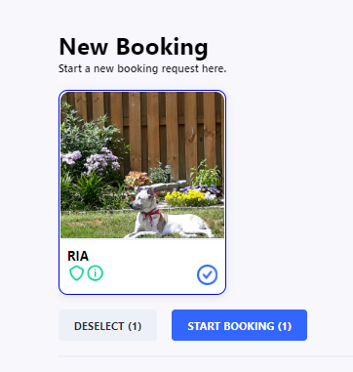

Choose BOOK A PLAYDATE from the Booking Category Dropdown

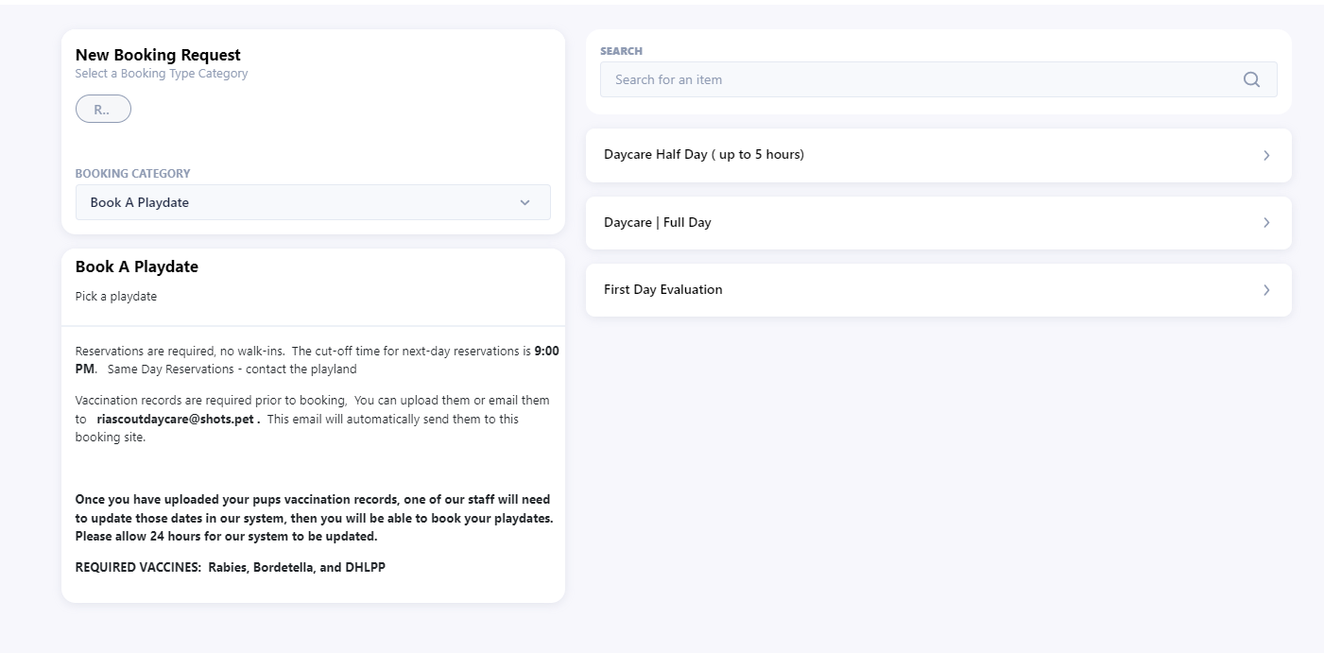
Then choose the type ( Full Day, Half Day or First Day Evaluation )
Pick the date and time for the playdate
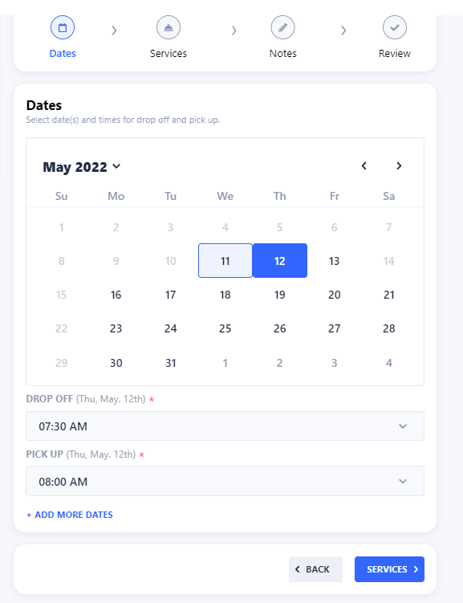

Then click on SERVICES
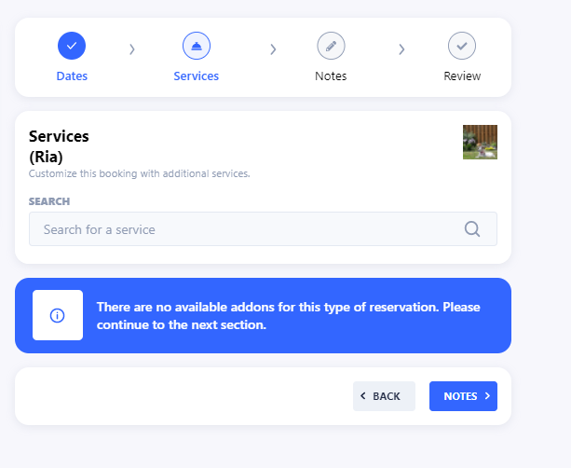
We do not have any services offered then click on NOTES
Add any notes for the reservation that you may want us to know
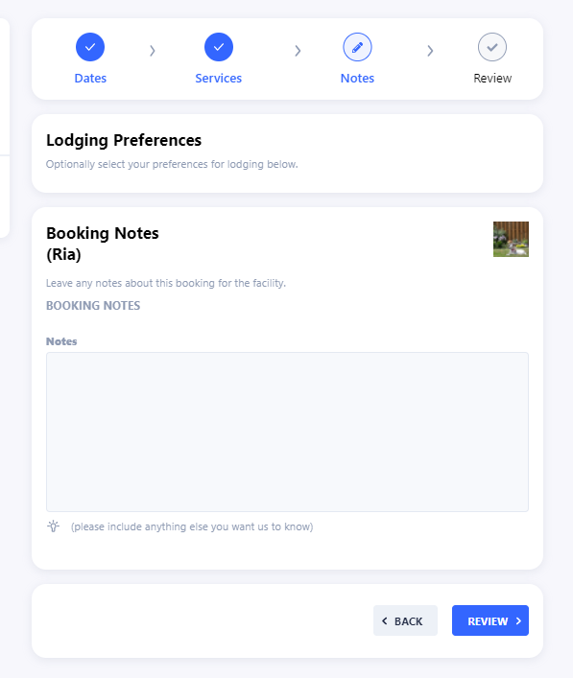
Then click REVIEW
If all looks correct, click on SUBMIT REQUEST
We will then send you an email confirmation
